**INTERNSHIP REPORT**



Internship Report submitted to the Department of Computer Science in partial fulfillment of the requirements for the award of

**BACHELOR OF SCIENCE IN COMPUTER SCIENCE**

Submitted by

## DINESH KUMAR Reg. No: 20UCS668

Under the guidance of

**Mr. Y. SUNIL RAJ , M.Sc., M.Phil..,Ph.D**

**DEPARTMENT OF COMPUTER SCIENCE ST. JOSEPH’S COLLEGE (AUTONOMOUS)**

*Special Heritage Status Awarded by UGC*

*Accredited at A++ Grade (4th cycle) by NAAC College with Potential for Excellence by UGC DBT-STAR & DST – FIST Sponsored College*

## TIRUCHIRAPPALLI-620 002

**JANUARY - 2022**

**DEPARTMENT OF COMPUTER SCIENCE**



# ST. JOSEPH’S COLLEGE (AUTONOMOUS)

*Special Heritage Status awarded by UGC Accredited at "A++ " Grade (4th Cycle) by NAAC College with Potential for Excellence by UGC DBT-STAR & DST-FIST Sponsored College*

## Tiruchirappalli-620 002

**Date : / /2022**

**CERTIFICATE**

This is to certify that the Internship report submitted partial fulfillment of there requirements for the award of the Degree of Bachelor of Science in Computer Science, is Bona-fide record of the work done by **DINESH KUMAR U**, **D.No**:**20UCS668** under my guidance during the year 2021-2022.

CO-ORDINATOR GUIDE

## (Prof. V.S Joe Irudayaraj) (Mr. B.SUNIL)

The viva voce examination of this internship report was held on at

St. Joseph’s College (Autonomous), Tiruchirappalli-02.

Internal Examiner External Examiner

## ACKNOWLEDGEMENT



First and foremost, I am graceful to the GOD Almighty, who has showered his blessing on me throughout this internship programme.

I profoundly thank **Rev. Dr. M. Arockiasamy Xavier SJ**, Principal, and **Dr.P.Rajendhiran.,** Deputy Principal, St. Joseph’s College (Autonomous), Tiruchirappalli-2, for providing me the opportunity to be a part of the institution.

My sincere gratitude to **Mr. Y . Dominic, MSc., MPhil., PhD.,** Dean, School of Computing Sciences, St. Joseph’s College (Autonomous), Tiruchirappalli-2, for motivating me to be a positive personality.

I express my sincere thanks to our beloved **Prof. A. Charles, MSc., PGDCA., MPhil.,** Head, Department of Computer St.Joseph’s College (Autonomous),Tiruchirappalli-2, for innovative suggestions and encouragements.

In a special manner I thank to **Prof. V.S Joe Irudayaraj, MSc., MPhil., PGDCA., MPhil(CS).,** Coordinator (Shift-II), Department of Computer Science, St. Joseph’s College (Autonomous), Tiruchirappalli-2, for encouraging me in every step.

I gratefully acknowledge my personal indebtedness to **Prof. Y. SUNIL RAJ**

**,M.Sc. , M.Phil.,Ph.D..,** who guided me with his scholarly valuable interventions.

I gratefully acknowledge my personal indebtedness to **Prof. Y. SUNIL RAJ**

**,MSc. M.Phil.,Ph.D,** my class-in-charge. And to other staff members of the Department of Computer Science, St. Joseph’s College (Autonomous),Tiruchirappalli-2.

I own a deep debt of gratitude to my **Parents and Friends** for their love and kindness which sustained my effort throughout my ideas.

**~DINESH KUMAR U**

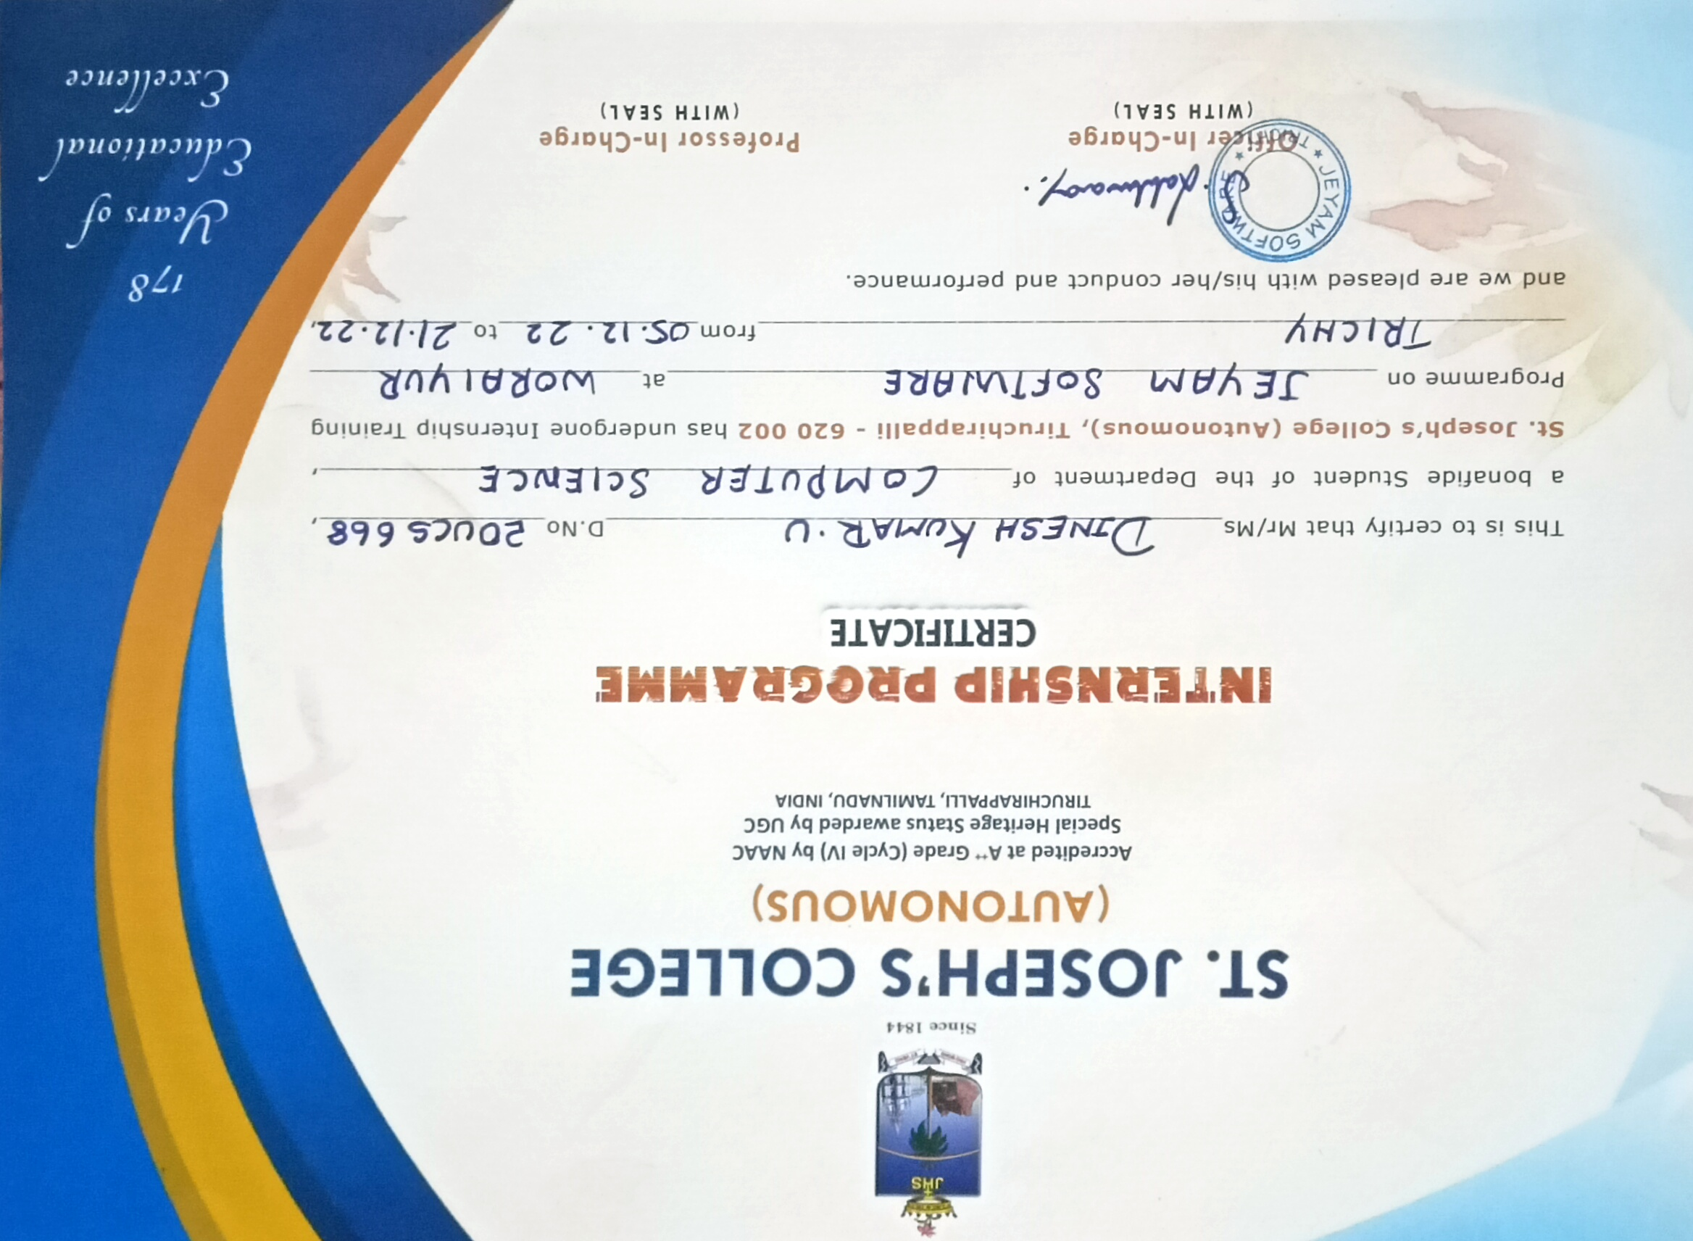



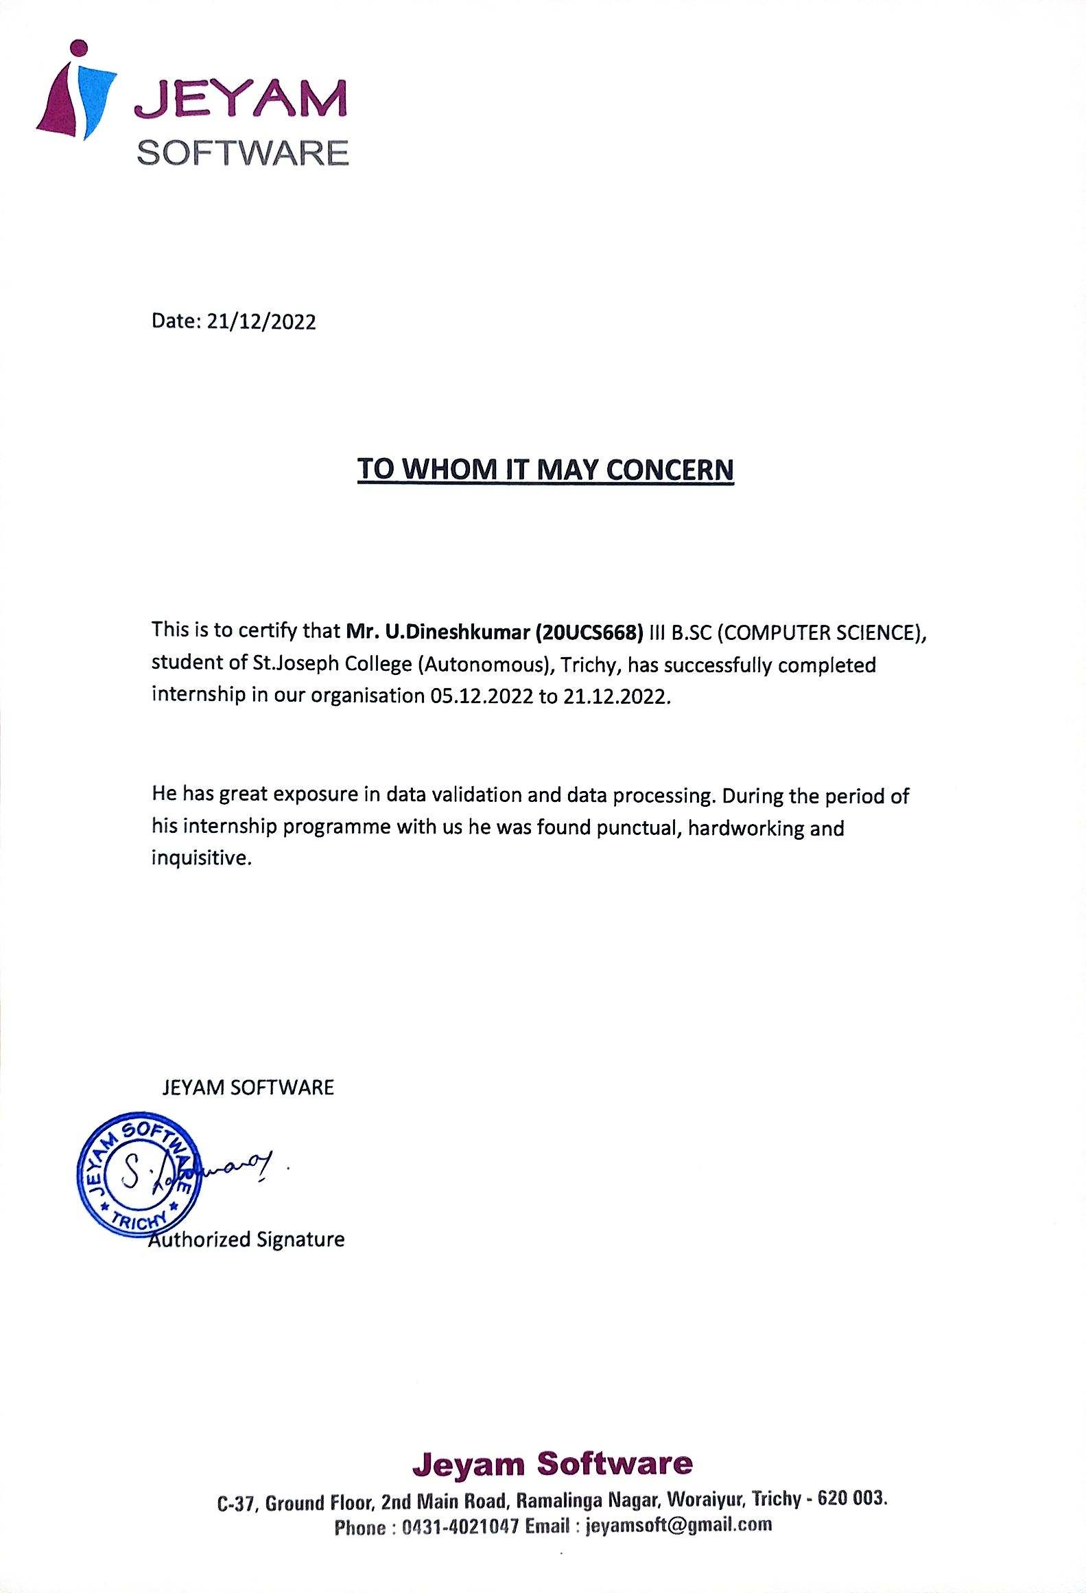

# CONTENT



|  |  |  |
| --- | --- | --- |
| **S.No.** | **Chapter** | **PAGE NO** |
| **1** | **INTRODUCTION** | 1 |
| **2** | **ORGANISATION PROFILE** | 2 |
| **2** | **2.1 ABOUT ORAGANIZATION** | 3 |
| **3** | **ROLES AND RESPONSIBILITIES** | 4 |
| **4** | **ACTUAL WORK DONE** | 5 |
| **5** | **LEARNING OUTCOME** | 8 |
| **6** | **CONCLUSION** |  |
|  | **APPENDIX** |  |
|  | **Daily work sheet** |  |
|  | **Certificate from Company** |  |
|  | **Photos Taken in the Company** |  |

# 1.INTRODUCTION



An internship is a learning situation where the student has the opportunity to gain practical experience.

When placed in this situation, students expand their concepts of different organizational structures and different working relationships within the workplace. In order to obtain academic credit for this experience, the intern is required to complete an Internship Report as described in section below.

The intern is expected to provide information on the organization, in which he or she worked, descriptions of specific work completed, and specific sports and or recreational aspects relevant to the assigned tasks.

The report also provides information on your communication skills and should indicate critical thinking skills. Since a major part of your experience should be related to either sports or recreation, that should be demonstrated in your report.

1

# 2.ORGANIZATION PROFILE



**Company Name :** JEYAM SOFTWARE

**Proprietor :** S. LAKSHMANAN.,

**Technical Assistance :** MOHAN RAJ BSc.,

**Address :** JEYAM SOFTWARE

C-37 Ground Floor,2nd Main Road,Ramalinga Nagar

Woraiyur,

Trichy – 620 003.

**E-mail :** [jeyamsoft@gmail.com](mailto:jeyamsoft@gmail.com)

**Mobile no :** 0431-04421047

**Technical employee :** 10 **Non technical employee :** 05 **Total Manpower** 15



# 2.1 ABOUT THE ORGANIZATION

In Jeyam Software they are having 12 systems which have been used for data entry , such as a checkclearing ,collection of checkbills etc .This company provide there services since 2012. In Jeyam Software there are having a well experienced workers. Both day and night shift was avilabale here.working time (9.00am to 5.00 pm) and (10.00pm to 6.00am). Basic skill needed (TYPE WRITTING). They are handling there employees friendly.

# 3. ROLES AND RESPONSIBILITIES



The Following activities have been performed by the Jeyam Software in woraiyur .

# Roles and Responsibilities : -

* **Data Entry**
* **Data Processing**
* **Check Clearing**
* **Technical Verification**
* **Outward Clearing**
* **Inward Clearing**
* **Output Generating**
* **Anylising fileds**
* **Portal Transfering**
* **Validation of Error**

# 4. ACTUAL WORK DONE ON MY INTERNSHIP



**Data entry is a type of clerical work that involves using various processes like typing and voice recording for entering data into computers. Data entry clerks work in a variety of industries including healthcare, finance, retail and transportation.**

## Day 01(05-12-2022): (Introduction about Business Process Outsourcing)

On my first day of internship,It is the practice of hiring another company to perform a

process that your own business needs to operate. In other words, you're using a third party

to handle non- primary business activities for the company.

.

## Day 02 (06-12-2022): (Introduction about Data Entry & Data Processing)

On my second day of internship, my guide taught me about Data entry & Data

processing .

## Day 03 (08-12-2022): (Brief Summary about Cheque Clearing Process)

On my third day of internship, the guide taught briefly about HDFC bank cheque clearing process , the process done between the 2-3 working days

## Day 04 (09-12-2022): (Steps to follow during Technical Verification of Cheque )

On my fourth day of internship, the steps for technical verification of cheque such as use only alphabets, don’t use special characters etc….

## Day 05 (10-12-2022): (Brief explanation about Outward Clearing Process which

## is followed in a Bank )

## On my fifth day of internship ,I was learn briefly about the outward clearing process of the cheque. Then I have worked in the process of outward clearing cheques

## 

## Day 06 (12-12-2022): (Brief explanation about Inward Clearing Process which



## is followed in a Bank )

On my sixth day of internship, I was learn briefly about the inward clearing process of the cheque. Then I have worked in the process of inward clearing cheques

## Day 07 (13-12-2022): (Analyzation of fields in a cheque and capturing the

## Same)

On my seventh day of internship verifying cheques. And find out the

Cheques with same data

## Day 08 (14-12-2022): (Checkpoints to be checked before submitting the output

## File)

On my eighth day of internship, I was checking before submitting cheque for the output files

## Day 09 (15-12-2022): (How to generate an output file?)

On my nineth day of internship, I was learn how to generate the output file for inward and outward cheque clearing process.

**Day 10 (16-12-2022):**  (**Steps to be followed while submitting the output file to**

**bank through file transfer portal)**

  On my tenth day of my internship, I was learn about steps which are followed

while submitting the output file to bank through file transfer portal

## Day 11 (17-12-2022): (Process to  be followed while doing Validation of

## ERRORS & Return Cheques)

## On my eleventh day of my internship, I have learn about checking the error

## Validation work for the return cheques.



## Day 12 (18-12-2022): (Work in the training files.)

On my twelth day of internship, I work with the plenty of training files that will help me to understand about the work clearly

## Day 13 (19-12-2022): (Work in the live files)

On thirteenth day of my internship, I work in the live files

## Day 14 (20-12-202): (Returing checks to the banks)

On fourteenth day of my internship, I was instructed to return the error cheques to the particular banks.

## Day 15 (21-12-2022): (I prepared my internship report and Receive the

## internship completion certificate )

## On my fifteenth day of internship also that was my last day , I was prepared the report for receiving the internship completion certificate

# 5. LEARNING OUTCOME



On this 15 days of my internship I had learnt about data entry and check clearing process such as inward, outward, errors etc… . And I learnt about how a business organization should be and also I learnt how consummate and how enthusiastic an employee must be for the welfare of the organization.

I think, I must attend more internship like that learned what is company pattern and what they are excepted from us. And that I through this is biggest opportunity for my carrier also. I learned how to behave in companies in future. This one keeps my carrier in hope. I gained lot of responsibilities in this internship.

# 6.CONCLUSION



I learnt many new ways of thinking and idea about the management of the company from the ten days of internship work rendered by our college. I also learned the way of dealing clients and how to run my own business, how to handle the company to higher level and what are the requirement need.

Moreover, if the internship period is within the bachelor internship work and the students have to return to the academic after completing it, the skills that they have developed during the internship help them to gain a more sound academic result and also learned some graphics designing technique which is used for designing my own profile. As this internship program has a great role in my future purpose and it will be useful.



